Enterprise Architecture & Network Project

Prepared For:

Cakes by Becky

Liaison: Business Owner

118 Harrison St

Williamston, NC 27892

<https://www.cakesbybecky.net/>

Prepared By:

MIS-4123 Team 1

Austin Clinefelter

Zachary Hurand

Caleb Brenner

Timothy Edgar

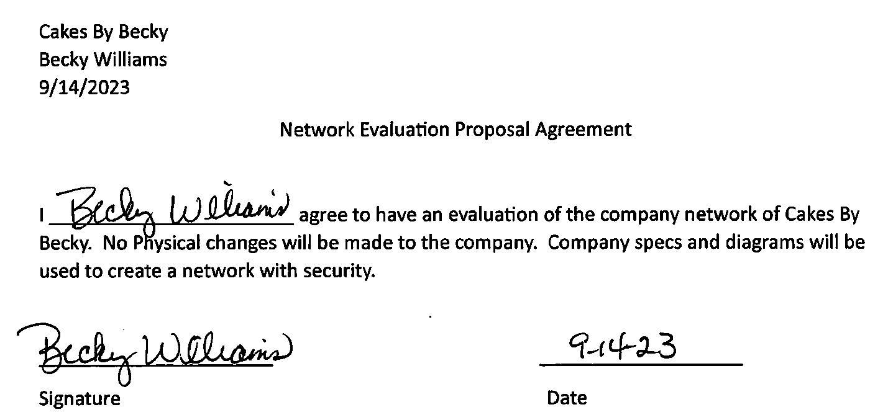

Table of Contents

**Introduction3**

Project Purpose3

Company Overview3

IT Governance………………………………………………………………………………………………………………………………………………………4

IT Governance Diagram...………………………………………………………………………………………………………………………………….…5

Enterprise Architecture………………………………………………………………………………………………………………………………………..5

Enterprise Architecture Diagram.………………………………………………………………………………………………….……………………..6

**Current Bakery6**

Floorplan……………………………………………………………………………………………………………………………………………………………..6

Floorplan Diagram ……………………………………………………………………………….……………………………………..……………………..7

Network………………………………………………………………………………………………………………………………………………………………7

Logical Design8

Logical Design Diagram8

Physical Design9

Physical Design Diagram9

**Vulnerabilities**9

**Needs Analysis10**

**GAP Analysis**……………………………………………………………………………………………………………………………………..…….…………… **11**

**SWOT Analysis11**

**SWOT Analysis Chart12**

**Recommendations12**

**Revised Bakery13**

Revised Physical Design13

Revised Physical Design Diagram15

Revisied Logical Design15

Revisied Logical Design Diagram17

**Budget18**

Components Price List…………………………………………………………………………………….…………………………………………………18

**Implementation and Timeline**19

**Disaster Recovery Plan**19

**Conclusion20**

**References21**

Introduction

Business Scenario

**Project Purpose**

Team 1 will be providing an audit of the company's network, Cakes by Becky. The network will be scanned to uncover any vulnerabilities in the company's network. A detailed report on the IT infrastructure, network security, personnel training, and network performance will be provided. The network assessment will give us an idea of the existing network's state and any needed improvements. A benchmark will be set to compare the final product evaluation.

The IT infrastructure comprises all the company's hardware, software, and facility components. Facility components include data centers, servers, hubs, and routers. All options must be studied and scanned for vulnerabilities. Any vulnerabilities will be noted and evaluated for solutions to secure.

Assessing the network security will consist of reviewing the company's intrusion detection. A firewall must be set up to monitor all incoming internet traffic and all customer network activity. An intrusion detection system will be installed for all intrusions entering the business. All security software and individual computer software will be upgraded consistently to apply the latest software patch.

Company personnel must develop a new style of thinking. All employees will be trained on how to prevent security threats. All personnel will have a responsibility that matches their business role to prevent cyberattacks. A little education can go a long way in keeping a business running smoothly.

Keeping the business continuity flowing smoothly can depend on the network performance. Hardware and software must be kept up to date. A network that performs up to speed will keep the company and customers running smoothly.

**Company Overview**

Cakes by Becky is a small business in Williamston, NC. The owner opened up the business in August of 2020. Initially, she only had one other employee and only offered limited pickup and delivery service, as it was during the COVID-19 pandemic. After a little over three years in business, there are six employees. The business runs six days a week with a fully functioning bakery and wedding cake service and delivery. Becky's previous business experience was running a bakery out of her home for about 20 years.

The bakery is a three-room business with a dining room, kitchen, and storage room. The storage room contains limited network components mixed with flour, sugar, and other baking ingredients. The room has no actual discernable pattern or layout. The network is basic and has few components or a security system.

The current business operates on a small internet presence. Orders are generally taken over the phone and a few by Facebook messenger. No orders are placed online or over email. Mrs. Williams would like to expand the business to include placing orders online. The concept has always been interesting, but the setup and security needed have always prevented her from completing the idea.

**IT Governance**

The IT governance at Cakes by Becky provides the structure for all decisions based on the information technology in the business. All decisions are made by the business owner. She is not technologically savvy, so she relies on advice from coworkers and friends. Darlene is the kitchen manager, and Ashley is the non-kitchen manager. Darlene and Ashley both provide advice on decisions. It is unknown if she is getting the best value out of the IT services at the bakery. The business goals do not align with her IT infrastructure, as she wants to start selling online but does not have the infrastructure to do so. The IT services and resources are currently not being managed in any order of structure. Risk management has never been assessed in the business or considered a possibility. It is essential to set up an IT governance at Cakes by Becky to give a sense of compliance, keep the business legal, and lower the risk of a cyberattack. The best IT governance framework for the business would be a Factor Analysis of Information Risk.

**IT Governance Diagram**

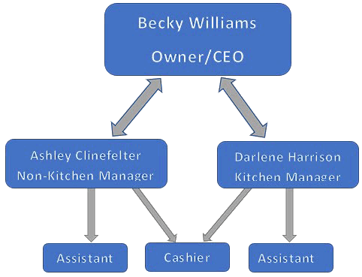

**Enterprise Architecture**

Cakes by Becky is a small business that only has three rooms. The business has basic Internet that ends up as wireless Internet throughout the business. All rooms are easily accessible to be hardwired or stay wireless. The business has options to upgrade its infrastructure as needed. The storage room would need to be rearranged to accommodate the needs of a digital upgrade.

Cakes by Becky can undergo a digital transformation to align with their long-term goals. The Internet would need to be upgraded, which is well within its means of structure and digital capacity. The storage room would need an area to act as a data closet, even if it's just in a corner. The wireless would need to be expanded to accommodate outside customers' future expansion. Hardwire internet lines would need to be run to allow expansion throughout the business. The new security would be a virtual install.

This business's enterprise architecture will help transform and upgrade possibilities. Mapping the business will allow for future expansion. A project management team will have an easier time upgrading physical and technological upgrades in the business. As the digital age constantly changes, upgrades will be a consistent opportunity. The team at Cakes by Becky is not big, but they will all understand the process mapped out for them.

**Enterprise Architecture Diagram**

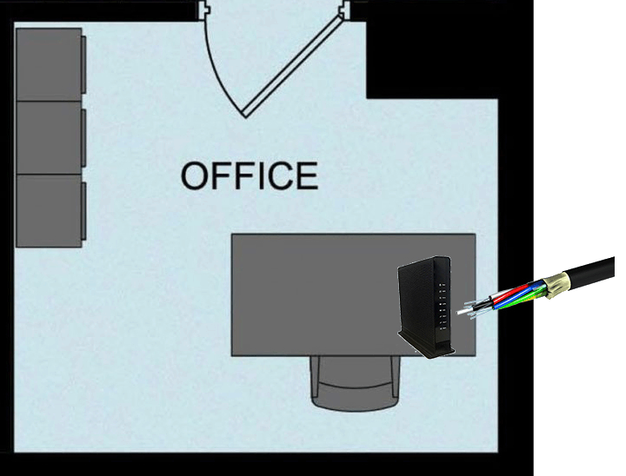

**Current Bakery Floorplan**

Cakes by Becky is a three-room small business. The most used room is a large kitchen with all appliances. The main room contains a sales area with a register and display. The main room has a small area to dine in or wait while your baked goods come out. You can also consult with your baker here to determine designs for your cake. The last room is an office in the back of the bakery. This office contains storage as well as a desk for working. The network comes into the business from this office. The modem/router is also in this room.

**Bakery Floorplan Diagram**

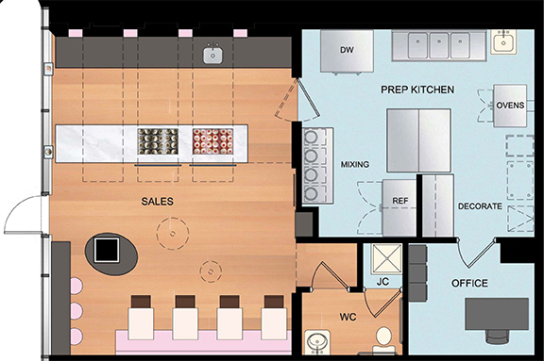

**Current Network**

Cakes by Becky has a limited network with no complexity or security. Their network is composed of older components. The owner understands the older components and helps Cakes by Becky focus on essential tasks needed to match business goals.

The network infrastructure is basic and consists of a single laptop computer. The computer is a 2017 Dell Inspiron Laptop with a 15-inch screen. The laptop has an old i3 processor, 8GB of RAM, and a 1TB non-solid-state hard drive. Bluetooth and wireless are supported with a network card for direct network connection. A printer is wirelessly hooked to the Internet and the laptop. This enables printing cake designs from wherever they happen to be in the bakery.

The network itself includes a basic Netgear modem/router. The Internet is a basic Optimum plan of 50 MBps. All devices are connected to a single network. Firewalls and detection systems are not present within the infrastructure. This is a small business with minimal customers; therefore, the small business has not acquired an infrastructure that is well protected. As the business grows and cyberattacks become more prominent, our group must come up with an upgrade to their network security, database, and file server and provide some insight for upgraded hardware. These small, successful businesses are low-hanging fruit and can be attractive to hackers.

No physical security is present in the business. There are no signs outside, or any way to tell the business is protected. One primary security camera is current inside but only has a live feed to a cell phone and is not backed up. The office where the network comes into the business does not lock. Cybersecurity is the only issue, but the lack of physical security can also attract hackers.

The current network is sufficient, although dangerous, for the business. The laptop provides the basic spreadsheets needed and a local area connection. Wireless Internet is provided throughout the business but goes no further. The logical and physical diagrams below show the current state of the network at Cakes by Becky.

The current heatmap internet signature is strongest in the office. The Internet has decreased by the time you reach the front of the building. The Internet is the slowest speed for a business coming in. The distance traveled and all the metal and steel in the building will decrease the Internet.

**Current Logical Design**

The current logical design is fundamental. Fiber optic internet comes into the business. The Internet is then routed to the laptop by ethernet or wireless throughout the business. Other devices, such as a printer, can wirelessly accept the Internet. The Internet is available throughout the business as needed.

**Current Logical Design Diagram**

**Current Physical Design**

The current physical design is a basic design. Optimum has a low package internet that provides a small bandwidth but is adequate for the few devices on the network. There is no intrusion or firewall security in place. A Netgear modem/router receives the internet and sends out a wireless signal. The router is password protected to only allow authorized users on the network. All employees log on to the wireless network to receive internet. An old printer, laptop and desktop computer also receive internet.

**Current Physical Design Diagram**

**Vulnerabilities**

The current design of Cakes by Becky has many vulnerabilities to its network security. Even though the network is small, threats can come from everywhere. Vulnerabilities should be assessed now to prevent future cyberattacks.

Properly trained employees can be one of the best defenses against a cyberattack. Employees should be trained on spotting malicious emails and webpages and when the email or page should be treated suspiciously. Passwords should be kept secure and be long and variable enough not to be cracked. All employee accounts should be set up with multi-factor authentication. Only the owner of Cakes by Becky should have access to sensitive files and customer data. With the low number of employees and no direct access to the network, the likelihood of occurrence is low with low risk and severity.

Currently, nothing is preventing malicious content from entering Cakes by Becky. A firewall should be implemented to monitor all incoming traffic through the network. A threat can easily infect the network without a firewall and possibly shut the business down temporarily. With no cybersecurity specialist on staff, all online orders could be shut down for weeks, causing thousands of dollars in lost revenue. With no firewall, the likelihood of occurrence is high, with medium risk and severity.

The age of the equipment is old at Cakes by Becky. Computers can fail, and all customer and business information can be lost without data backup. North Carolina is known for natural disasters, specifically hurricanes. A hurricane can cause damage to the building itself from wind or flooding the building. Either way, a loss of data can occur. A backup system should be installed to prevent any loss of data. Due to the age of the computer and the occurrence of hurricanes, the likelihood of occurrence is high with medium risk and severity.

**Needs Analysis**

Cakes by Becky is a small business bakery. The business needs to expand to include taking orders over the Internet and email and expanding the wireless capability to allow customers outside to access the Internet. The current system will not be sufficient to handle the new demand and will be vulnerable to cyberattacks.

The goal for the network at Cakes by Becky is to provide a proper framework and network to allow the business to expand as needed. The business will have several needs to accomplish its goals.

Specific network components will need to be purchased. A new laptop to run the system. A server to house the database management system. An upgraded modem/router from their internet service provider to go along with increasing their bandwidth. An access point will need to be installed in the dining room area.

Software and cloud services will be needed. A simple firewall with a small business in mind will be required. A firewall can used as software or cloud-based. With the increased bandwidth and low traffic, either method will work fine. A cloud backup system will also work great with the new setup to allow a reliable backup with little to no action needed by the staff. A simple database management system will be required to catalog customer data safely and securely, but it is easy to access.

A disaster recovery plan must be implemented even with all the new equipment and software. The plan will outline how the business will run in the event of a cyber or natural disaster. Who will be called to repair the system if there is a failure? Who will help to recover lost data? Who will analyze and remove infections from the system? How will the business get back up and running?

A business continuity plan will also need to be put in place. This plan will outline how the business will run in a disaster. Will the business shut down? How will the bakery remain open while the network is being repaired? How can we decrease any lost customers? Without a business continuity plan, customers and revenue will indeed be lost.

**GAP Analysis**

A GAP analysis will highlight an organizations current state and measure what improvements need to be implemented to acquire their desired state. A GAP analysis will measure the areas of the business that need to be improved. A GAP analysis can be dissected further than a SWOT analysis but both methods should be used. As Cakes by Becky starts to reach a larger audience, they will need to enhance their detailed network, increase security, update their technology, and incorporate employee training. With a monetary value that is relatively expensive, our group has come up with a budget for Cakes by Becky that we think they should incorporate to exploit these vulnerabilities and be worry free when it comes to cybersecurity. A GAP analysis should occur by assessing their current state, defining where they want to be, identifying the gaps the business has between their current state and desired state, coming up with an action plan to acquire their desired state, and then implementing their action plan. Our group has come up with two GAP forms for Cakes by Becky below.

**GAP Analysis Forms**

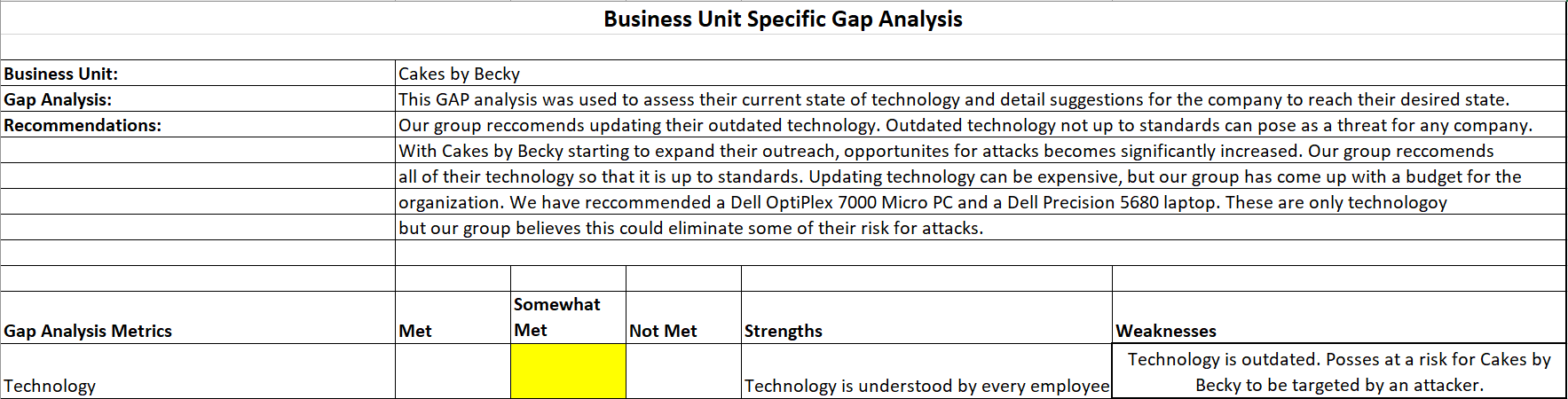

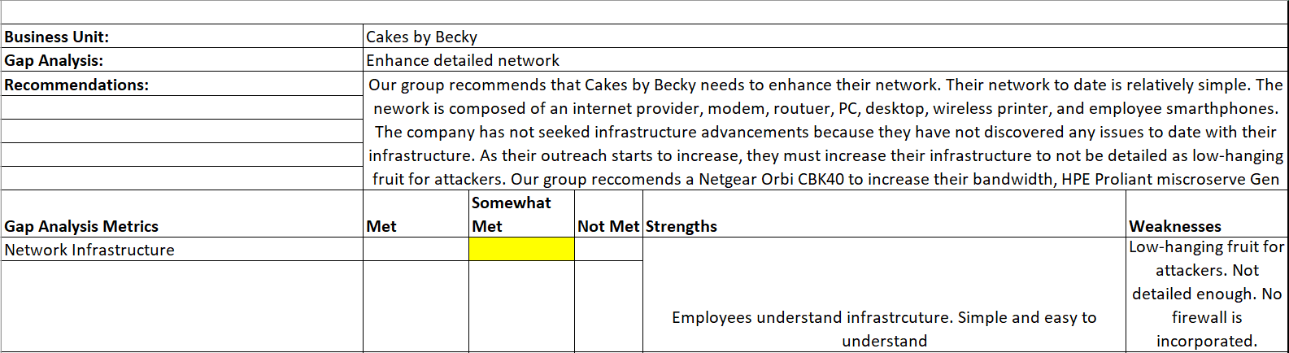

**SWOT Analysis**

The SWOT analysis for Cakes by Becky focuses on her small network for her bake shop. The strength of this business is the scalability as she can expand a good amount but then cut back if needed on her network. She also has a good customer satisfaction rating, which will help bring in more customers when she expands. Her loyal customer base and reliable employees will help to keep the business running.

The opportunities for Cakes by Becky mainly involve security and expansion. She can add network security and a firewall to make her system flow and be safer. The new system will allow her to expand her business to online orders and outdoor seating. Upgrading her applications will help her run the business smoothly.

The main weaknesses of the business involve security and the Internet. The owner does not know much about network applications or business. We fear that her network could be tampered with. The business has little physical security as well as cyber security.

The biggest threat we've discovered would be the lack of network security. The entire security of her network is weak and lacks a firewall. The age of her equipment is pretty old, which slows down all of her operations.

**SWOT Analysis Chart**

|  |  |
| --- | --- |
| Strengths | Weaknesses |
| * Small business * Customer Satisfaction * Scalability * Loyal Customers * Family Style Business * Reliable Employees | * Flow state of network * Weak Internet * No security * Lack of knowledge * No business sense |
| Opportunities | Threats |
| * Network Security * Upgraded Firewalls * Expansion * New applications | * No Firewall * Lack of security * Age of equipment |

**Recommendations**

Cakes by Becky has several needs that we recommend. Overall, the system needs security installed inside and out to prevent threats.

The following physical security is recommended:

* Signs on the outside to let people know the property is being monitored
* New deadbolt locks on the exterior doors
* New locks to the office door that has network equipment in it
* Security cameras installed inside and outside
  + Cameras are recorded and backed up
* An alarm system will be installed in case of a break-in

The following cyber security is recommended:

* A new laptop
* A server
* A Database Management System
* Modem/Router
* Access point
* Firewall
* Ethernet cable
* Cloud backup system

**Revised physical system**

When designing the new system for Cakes by Becky, we wanted to put proficiency and security first. There will be a small server closet in the office and a modem, router, and switch so that printers and computers can access the network. The office will have one Tower PC and a laptop with an operating system of Windows 11. A dedicated database server will use MySQL as the database management system. This is where all customer data will be stored and accessible when needed.

The components will all be purchased new. The tower rack will contain the PC and server. A Dell OptiPlex 7000 is a micro PC that will help with the small space and run the server. A 12 gen i5 processor will be adequate to run the processes needed but not get overloaded. 16 GB of RAM and 512 GB of solid-state hard drive will be enough to run a small business. Windows 11 will provide some extra security. Bluetooth and WiFi will be available, but the system will use its Network Interface Card and an ethernet cable to access directly to the router. Also, the tower has an HPE Proliant micro server Gen 10 V2. This is also a small form component with 16 GB of RAM, a 1TB solid-state hard drive, and a Xeon processor. A Dell Precision 5680 laptop will be a portable workstation for flexibility in office and customer work. The modem/router will come with Optimum as a Netgear Orbi CBK40. A Cisco Business 110 series unmanaged switch will provide enough access and stay in line with a small business. An AX6000 Tri-Band PoE Multi-Gig WiFi 6 access point will be set up in the main room to provide enhanced WiFi for customers inside and outside the bakery. Two hundred feet of ethernet cable will be required to hook up the access point along with the desktop PC and occasionally the laptop PC and the security cameras.

# Four ethernet-wired security cameras will be set up inside and outside the bakery. Verkada CD22 dome cameras will be installed to provide excellent coverage. Three cameras will be installed inside the business and one outside the business. The high-definition cameras will show clear footage when needed. All camera footage will be accessible in the office and backed up to a cloud service to track and save all data. The cloud service will provide complete security and service that would not be able to be provided by the staff at this small business.

A firewall will be implemented to protect the servers from unauthorized access. A Cisco Secure Native Cloud-based firewall will be set up. This firewall is perfect for a small business. It is inexpensive but blocks most incoming threats a small business might face. This can even be purchased through Amazon to simplify and simplify the purchase experience.

MySQL Heatwave will be used as the database management system. This system is relatively simple to use and offers the functionality that a small business needs. This system can be set up directly on the server. Heatwave is a fully functioning database service that combines transactions, analytics, and machine learning services into one MySQL Database. This version of MySQL will be perfect for a small business.

Data encryption will be a big part of security purposes, such as passwords and payment information. All software and libraries will be updated to prevent any vulnerabilities. Any software patches should be kept current, including all components and software. The cloud services will update the cloud-based systems. We must implement real-time monitoring and logging to detect and respond to security incidents.

With a whole new system being implemented, user training will be a big part of transitioning to the new system. We will educate users about security best practices and the importance of strong passwords. With only six employees and four part-time employees, I don't see any need to hire an outside agency. The non-kitchen manager can be easily trained, and then she will train the other five employees.

Data backups will occur in a cloud-based system. Cloud-based systems are inexpensive and easy to set up. Data can be backed up with little to no experience needed from the client. AWS cloud services offer simple packages that can be set up quickly. These packages are secure and reliable for a small business.

**Revised Physical Diagram**

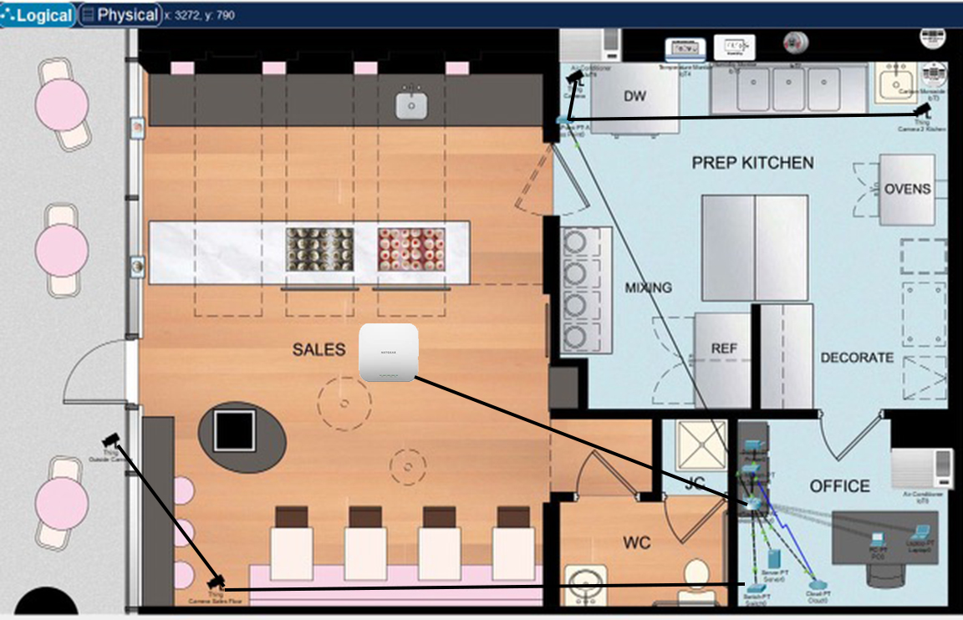

**Revised Logical Network**

The logical network has changed drastically. Many new components have been added to upgrade the network in the small business. The revised design has dramatically enhanced the network.

The Internet coming in is still fiber optic coming from optimum. Fiber is the fastest speed you can get and the most reliable. The bandwidth was increased up to 1GB. This increase is necessary to enhance the network and the wireless capabilities. Cloud services are now being used for data backup and firewalls. This requires more bandwidth to handle the increased up-and-down traffic.

Wireless capabilities are increased with the new design. A new router with the increased bandwidth will enhance the WiFi. A wired access point in the main room has been installed to provide wireless Internet to customers inside the business. Wireless Internet will also be provided for the new seating arrangement outside.

Security cameras are added to the network. The cameras are hardwired to the network to allow the footage to be backed up and viewed from the cloud. The view footage will be stored on the cloud for easy use.

A switch in the main office will also allow communication between multiple devices in the business. The network will be able to be routed to the desktop, laptop, and access point, as well as allowing the security cameras to interact with the desktop computer before going to the cloud.

The logical design can be carried out by turning a section of the office into a data closet and putting a data rack in. The closet will hold all of the components. The components will all be wired together on the data rack. The ethernet cables will exit the rack and closet and enter the rest of the business through the ceiling. Ethernet cables will connect the camera and access points from the switch. Two air conditioners will be added to the office to keep the closet, rack, and all components in the 65 to 70-degree range.

**Revised Logical Diagram**

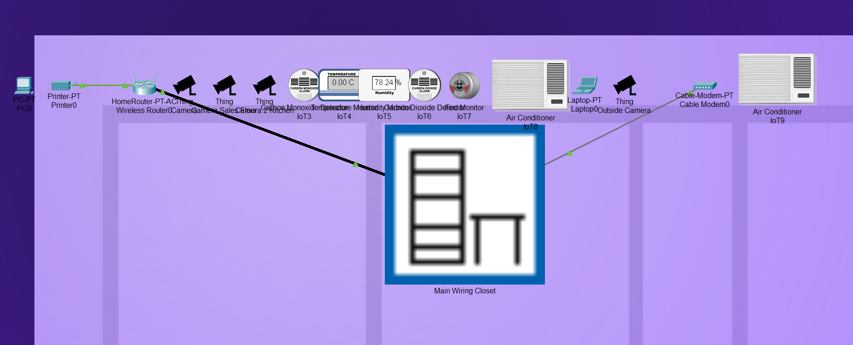

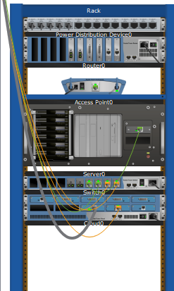

**Budget for the Network Design Project**

Cakes by Becky has a budget for the current network project. Currently, the only cost the company pays is their internet fee of about $75/month. This account is for renting the existing modem/router. The current cost may seem low; however, losing thousands of dollars only takes one cybersecurity incident. A small business bakery with an average-size database would lose about $1000 weekly. Then, there is also the possibility of lawsuits from customers who had their information stolen. It is better to invest a little money now than to pay later.

**Budget**

Cakes by Becky is a small privately-owned business. The owner understands that she has to invest some money in to this project in order to have a secure system. The business will be improved and should make more money with taking online orders and expanding to have outside seating. The budget for this project was $7500. We went over budget by a little over one thousand dollars. The group felt our components and prices were necessary and we did not want to compromise. Except for a small annual fee for MySQL, it is a one-time charge.

**Components Price List**

|  |  |
| --- | --- |
| Component | Price |
| Dell OptiPlex 7000 Micro PC | $879 |
| Netgear Orbi CBK40 | $175 |
| HPE Proliant microserver Gen 10 V2 | $1,206.04 |
| Dell Precision 5680 laptop | $2,799 |
| Cisco Business 110 series switch | $58.54 |
| AX6000 Tri-Band access point | $330.07 |
| 200' of ethernet cable | $23.97 |
| 4 Verkada CD22 dome cameras | $999.99 |
| Cisco Secure Native Cloud | $595 |
| MySQL Heatwave | $0.35 per hour |
| 2 Air Conditioning units | $1500 |
| Total | **$8,566.61** |

**Implementation plan and timeline**

The implementation of the new network will be completed in about one month. The desktop and laptop will be ordered from Dell on day one and would expect to be delivered and set up within ten days. Optimum should come within one week to increase the bandwidth and set up the new modem/router. An HPE server can be ordered directly from Hewlett-Packard and delivered and set up within ten days. A Cisco switch can be ordered and set up in two weeks. The access point is a Netgear product that can be ordered and ready in ten days. Two hundred feet of ethernet cable can be picked up locally or ordered from Amazon. Either way, the ethernet cable should be prepared in one week. The four security cameras can be requested from Verkada and delivered in ten days. MySQL heatwave can be deployed on Amazon Web Services and can be ready in as little as one day. Data backup can also be set up on Amazon Web Services and be prepared. The last component is two air conditioners, which can be picked up at Lowe's and installed in one week. All components will be here within two weeks. A trained professional must perform the final installation and link of all components. That puts everything completed within one month.

**Timeline**

|  |  |
| --- | --- |
| Event | Timeline (to completed) |
| Dell OptiPlex 7000 Micro PC | Ten days |
| Dell Precision 5680 laptop | Ten days |
| Optimum internet bandwidth increase | One week |
| Netgear Orbi CBK40 | 1 week |
| HPE Proliant microserver Gen 10 V2 | Ten days |
| Cisco Business 110 series switch | Two weeks |
| AX6000 Tri-Band access point | Ten days |
| 200' of ethernet cable | One week |
| 4 Verkada CD22 dome cameras | One week |
| Cisco Secure Native Cloud | Ten days |
| MySQL Heatwave | One day |
| AWS data backup | One day |
| 2 Air Conditioning units | One week |

**Disaster Recovery Plan**

Security is a big issue we have with the Cakes by Becky business. If a disaster strikes, the business needs to be prepared and have a disaster recovery plan. This plan will get the business back up and running as quick as possible. As the business is small, the same plan will be used for fire, natural disaster, and a cyber-attack. The longer the business is down, the more lost revenue occurs. A contracted IT company will be responsible for the recovery. All applications should have been listed as to whether they are critical and need to be back up as soon as possible or if they can wait.

The first step is to scan and verify all computer, servers, and databases for compromises. Once the systems are back up and running and free of infection, data can be restored. We have already recommended a cloud-based backup solution through AWS. This will eliminate data issues the company could have in the case of a disaster and be able to recover any lost data. We recommend consistently backup any data on a regular basis to fight against any freak accidents like a fire, natural disasters etc. Once data is restored, all non-critical applications can be verified rebuild if necessary. One last method is to keep up with security checks, have a staff member check in to see if any malicious activities have been happening in the system. Any changes in the disaster recovery plan should be documented and kept safe. A copy of the disaster recovery plan should be kept in a secure location outside of the business.

The physical security should be verified occasionally and reworked if needed. Security signs should be visible and, in a location, where the public can spot them. Outdoor security cameras should be verified for working condition. The camera system is back up to the AWS cloud for easy access and retrieval. Locks should be in working conditions and changed every 5 years to up to date. A security system is installed on the doors and windows for any break-ins. Indoor security cameras are installed inside the bakery for easy access and visibility of footage. Indoor camera footage is also backed up to the AWS cloud.

**Conclusion**

Cakes by Becky is a small business that serves a small county of 21,290 people. The business does well as she is mainly the only bakery in the county. Currently, all orders are taken in person or over the phone. The bakery has much room to grow and can take orders online and by email. The business can be expanded to include outside seating. All the additions can be possible by adding some components and increasing bandwidth.

An initial assessment was completed on the small business. Vulnerabilities were revealed of possible cyber infections from an outside hacker or an accidental employee reveal of the network. A needs assessment revealed a need for security, both physical and cyber. The security will fit perfectly with the new components. A cloud backup service should be set to prevent customer- or business-related loss and data.

Our team made recommendations that will help Cakes by Becky complete her upgrades within a one-month timeframe. Two computers, a modem/router, a switch, an access point, and four security cameras are all she needs to make her dream a reality. With some employee training, the business will be ready to enter the new market.

References

"Cisco Secure Firewall." *Cisco*, 22 Sept. 2023, www.cisco.com/site/us/en/products/security/firewalls/index.html.

Estrach, Paul. "What Is Enterprise Architecture (EA), and Why Is It Important?" *MEGA*, 11 Jan. 2023, www.mega.com/blog/what-is-enterprise-architecture-definition.

Hunt, Marsha. "Free." *Amazon*, Plume, 1994, aws.amazon.com/ebs/?did=ft_card&trk=ft_card.

Kimball, Matt. "Is MySQL Heatwave Oracle's 'Killer App' ?" *Forbes*, Forbes Magazine, 30 Mar. 2023, www.forbes.com/sites/moorinsights/2023/03/29/is-mysql-heatwave-oracles-killer-app-/.

Lindros, Kim. "What Is It Governance? A Formal Way to Align IT & Business Strategy." *CIO*, 31 July 2017, www.cio.com/article/272051/governanceit-governance-definition-and-solutions.html.

Williams, Becky. "Cakes by Becky." *Cakes By Becky*, 19 Jan. 2023, www.cakesbybecky.net/.